# Project 1 Design Document

## Section 1 – Problem to be Solved

* A membership club needs a program to keep track of a club and its members.
* A Java Program is written to do so.

## Section 2 – Inputs, Outputs, and Processing

### Inputs

* Asks the user for a username. Accepts a String input.
* Button Input in the Menu for:
  + Creating a new member
  + Displaying a member
  + Exiting the Program
* When creating a new member, accepts String input for the member’s:
  + First Name
  + Last Name
  + City
  + State
  + Date Joined
  + File path to the user’s photo.
  + Member Type – [This is done using button input, rather than the user having to type it in.]

### Outputs

* When reaching the menu, asks the user to choose an input option (like Creating a member)
  + When the user picks “Create a Member”, the user is guided through creating a member with outputs asking the user for the member’s attributes.
* When choosing “Display a Member”, shows either an error message (if the user has not yet created a member), or a message showing the created member’s attributes.
* When exiting the program, the system thanks the user for using the program before ending the program.

### Processing

* Determining whether a field requiring user input is empty/blank.

## Section 3 – Responsibilities for each Class

### MemberDriver.java

* Contains the main method that runs the program.
* Creates member class(es) and utilizes MemberType.java.

### Member.java

* Holds the attributes inputted by the user in MemberDriver.java.
* Has accessor and mutator methods as well as a toString() method, allowing MemberDriver.java to easily access each of the member’s attributes.

### MemberType.java

* An enum that holds constant values for member types such as Officer, Provisional, etc.
* Used by MemberDriver.java

## Section 4 – UML Diagram and Relationships

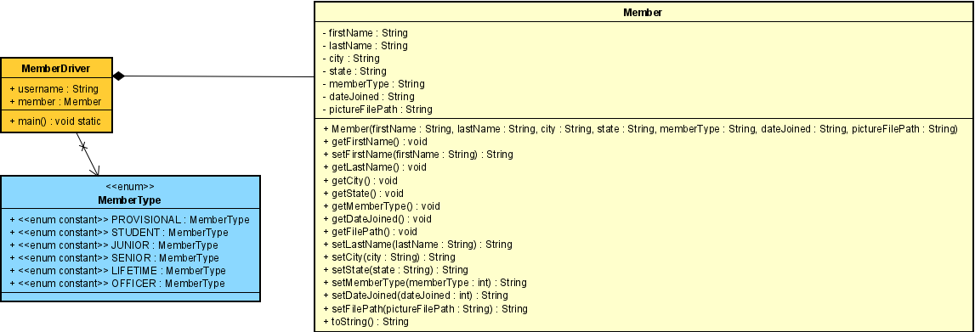

* The Member class is part of the MemberDriver class. The MemberDriver class cannot exist without the Member class.
* The MemberDriver class references MemberType enum constants while running.

## Section 5 – Major Algorithms

### MemberDriver.java

* Operation: main()
* START
  + Define String username & Member member.
  + INPUT username.
  + Show menu. CHOOSE options (button input for “Creating a Member”, “Display a Member”, “End the Program”).
    - When choosing “Create a Member”:
      * INPUT firstName
      * INPUT lastName
      * INPUT city
      * INPUT state
      * INPUT memberType (button choice)
      * INPUT dateJoined
      * INPUT pictureFilePath
      * IF(firstName is Blank), firstName = Barney
      * IF(lastName is Blank), lastName = The-Dinosaur
      * IF(city is Blank), city = Johnson City
      * IF(state is Blank), state = TN
      * IF(dateJoined is Blank), dateJoined = 01/01/2000
      * IF(pictureFilePath is Blank), pictureFilePath = firstName + lastName + “.jpg”
      * Create new member(firstName, lastName, city, state, memberType, dateJoined, pictureFilePath)
    - When choosing “Display a Member”
      * IF(member is not NULL)
        + Display member attributes (member.toString()).
      * ELSE
        + Show error message “Sorry, there are currently no members.”
    - When choosing “End the Program” or X
      * Display the message “Thank you, “ (Username) “, for using Club Membership Roster!”
      * Ends the Program.

## Section 6 – Test Cases

* Test values here are done chronologically.

|  |  |  |  |
| --- | --- | --- | --- |
| Variable | Input | Result/Output | processing |
| Username | Johnson | Welcome, johnson! Please select an option. |  |
| Username |  | Welcome, username! Please select an option |  |
| Menu | Display a Member | There are currently no members! Please create a member. |  |
|  | End the Program | Thank you, (Username), for using Club Membership Roster! |  |
|  | Create a Member | What is the Member’s First Name? |  |
|  |  |  |  |
| Firstname | John | What is the member’s last name? |  |
| Firstname | “Cancel” | (Menu) Welcome, username! Please select an option | Returns to the Menu. |
| Firstname |  | What is the member’s last name? | Firstname = Barney |
|  |  |  |  |
| Lastname | Rake | What city does the member live in? |  |
| Lastname | “Cancel” | (Menu) Welcome, username! Please select an option | Returns to the Menu. |
| Lastname |  | What city does the member live in? | Lastname = The-Dinosaur |
|  |  |  |  |
| City | Atlanta | What state does the member live in? |  |
| City | OEUrowenofnw | What state does the member live in? |  |
| City |  | What state does the member live in? | City = Johnson City |
|  |  |  |  |
| State | GA | What is the member's classification? |  |
| State | IUwnefasdcv | What is the member's classification? |  |
| State |  | What is the member's classification? | State = TN |
|  |  |  |  |
| MemberType | (Button Input) | When did the member first join the club? Enter as mm/dd/yyyy. |  |
|  |  |  |  |
| dateJoined | 05/22/2012 | What is the filepath to the member's photo? |  |
| dateJoined | Notadate | What is the filepath to the member's photo? |  |
| dateJoined |  | What is the filepath to the member's photo? | Date Joined = 01/01/2000 |
|  |  |  |  |
| pictureFilePath | Johnrake.jpg | (Menu) Welcome, username! Please select an option |  |
| pictureFilePath | Notafilepath | (Menu) Welcome, username! Please select an option |  |
| pictureFilePath |  | (Menu) Welcome, username! Please select an option | pictureFilePath = firstname +  lastname + “.jpg” |
|  |  |  |  |
| - | Display a Member | Rake, John  ---------------  Address: Atlanta, GA  MemberType: PROVISIONAL  Date Joined: 05/22/2012  Image File Path: johnrake.jpg | (Results may vary, depending on data inputted when creating a member. This example is based on correctly inputted values.) |
|  |  |  |  |